Xocotepetl

Actividad de aprendizaje 14. Desarrolla un proyecto que administre una base de datos.

Es recomendable visualizar esta tarea desde el siguiente enlace  
<https://github.com/davi3004/Xocotepetl>

# Integrantes:

* David Nájera Escobar
* Fabiola Ramírez Negrete
* Sergio Eduardo Islas Romero

# Nombre del sistema

Xocotepetl

# Descripción breve de la problemática

El dueño de una chocolatería llamada Xocotepetl tiene dificultades para mantener el control del inventario de su negocio. Actualmente, lleva el registro de los productos y el inventario de forma manual en una hoja de cálculo, lo que hace que el proceso sea propenso a errores y poco eficiente.

# Solución propuesta

Se propone desarrollar un sistema de inventario automatizado llamado Xocotepetl, que permita al dueño de la chocolatería llevar un registro preciso y eficiente del inventario de su negocio. El sistema permitirá agregar, editar y eliminar productos del inventario, y también permitirá calcular el costo total de los productos que se van a llevar y generar un ticket de compra para el cliente.

El menú que se tomará en cuenta para la creación de la base de datos será el siguiente

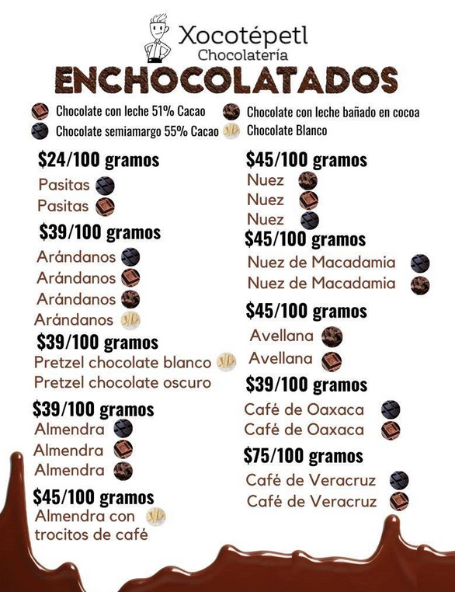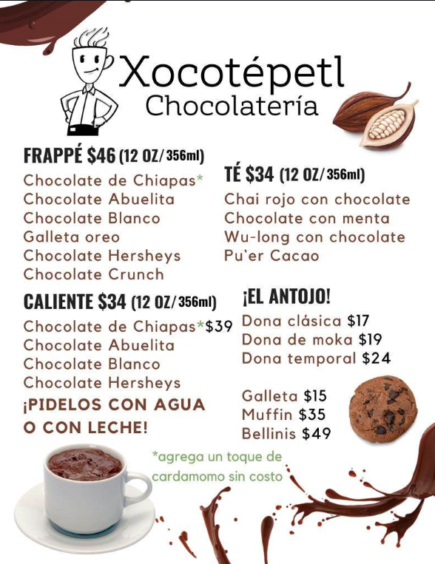

# Diagrama de la base de datos

El diagrama de la base de datos será el siguiente:

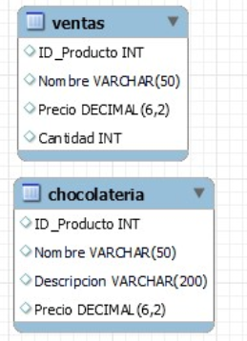

Las tablas que tendrá serán las siguientes:

## Tabla chocolateria

Esta tabla tendrá el inventario, y sus datos, algunos datos pueden variar de acuerdo con la tabla debido a las pruebas realizadas.

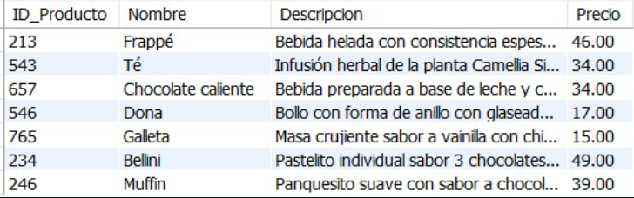

## Tabla ventas

Esta tabla tendrá las ventas al momento, y sus datos, algunos datos pueden variar de acuerdo con la tabla debido a las pruebas realizadas.

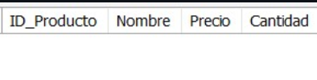

# Código de base de datos

Ahora bien, el código fuente de la base de datos es el siguiente.

|  |
| --- |
| DROP TABLE IF EXISTS Chocolateria;  CREATE TABLE Chocolateria (  ID_Producto INT,  Nombre VARCHAR(50),  Descripcion VARCHAR(200),  Precio DECIMAL(6,2)  );  LOCK TABLES `Chocolateria` WRITE;  INSERT INTO `Chocolateria` (ID_Producto, Nombre, Descripcion, Precio) VALUES (213, 'Frappé', 'Bebida helada con consistencia espesa semejante a la de un helado.', 46.00);  INSERT INTO `Chocolateria` (ID_Producto, Nombre, Descripcion, Precio) VALUES (543, 'Té', 'Infusión herbal de la planta Camellia Sinensis, se puede preparar frío o caliente.', 34.00);  INSERT INTO `Chocolateria` (ID_Producto, Nombre, Descripcion, Precio) VALUES (657, 'Chocolate caliente', 'Bebida preparada a base de leche y chocolate blanco u oscuro.', 34.00);  INSERT INTO `Chocolateria` (ID_Producto, Nombre, Descripcion, Precio) VALUES (546, 'Dona', 'Bollo con forma de anillo con glaseado de glass, chocolate o maple.', 17.00);  INSERT INTO `Chocolateria` (ID_Producto, Nombre, Descripcion, Precio) VALUES (765, 'Galleta', 'Masa crujiente sabor a vainilla con chispas de chocolate belga o avena con pasas.', 15.00);  INSERT INTO `Chocolateria` (ID_Producto, Nombre, Descripcion, Precio) VALUES (234, 'Bellini', 'Pastelito individual sabor 3 chocolates sellado con mousse de chocolate.', 49.00);  INSERT INTO `Chocolateria` (ID_Producto, Nombre, Descripcion, Precio) VALUES (246, 'Muffin', 'Panquesito suave con sabor a chocolate con chispas o vainilla con mora azul.', 39.00);  UNLOCK TABLES;  DROP TABLE IF EXISTS Ventas;  CREATE TABLE Ventas (  ID_Producto INT,  Nombre VARCHAR(50),  Precio DECIMAL(6,2),  Cantidad INT  );  LOCK TABLES `ventas` WRITE;  UNLOCK TABLES; |

# Limitaciones

Algunas de las limitaciones son las que cuenta el software son las siguientes:

* Dificultad para almacenar el stock, debido a que son bebidas preparadas, se hacen al momento, es decir no hay posibilidad de hacer el conteo sin los ingredientes.
* Guardar ventas anteriores, debido a que la base de datos "ventas" se usa para anotar los productos vendidos entonces se borra cada que se sale del programa o se imprime el ticket

# Errores

El software tiene un error donde está la caja de cobro, al añadir o eliminar un objeto de la tabla salen muchos errores, pero esto no afecta al funcionamiento del sistema.

# Software

La clase principal se llama Xocotepetl.java

Para usar el software es necesario modificar la siguiente parte del código dentro de la clase Conexion_interac.

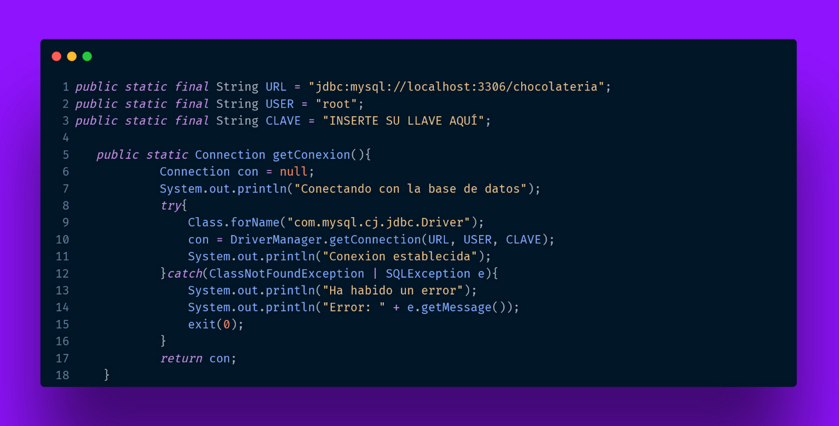

El apartado que se debe cambiar es donde dice INSERTE SU LLAVE AQUÍ.

El software además puede ser ejecutado descargando y configurando todo, para esto recomiendo usar.

* MySQL
* Apache NetBeans IDE 17
* Java: 19.0.2; Java HotSpot(TM) 64-Bit Server VM 19.0.2+7-44

A continuación, se muestra un ejemplo del uso del sistema, este sistema puede ser descargado y ejecutado como se mencionó anteriormente.

# Capturas

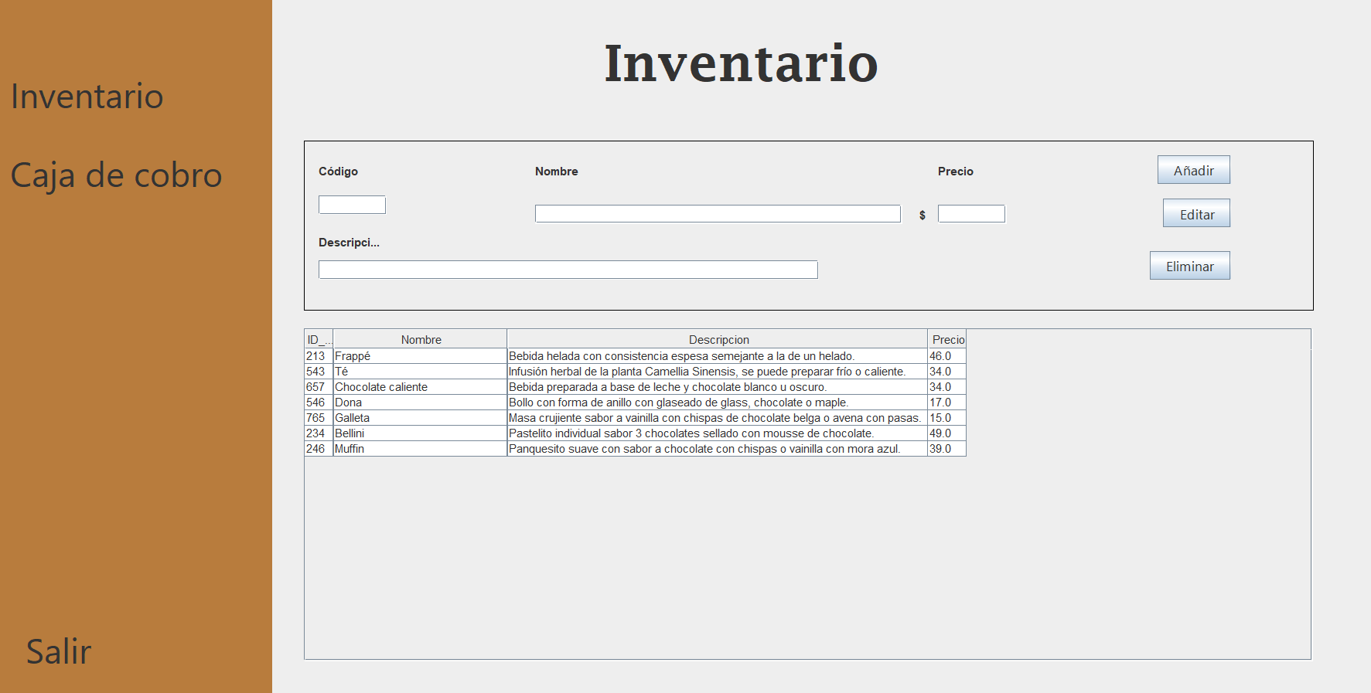

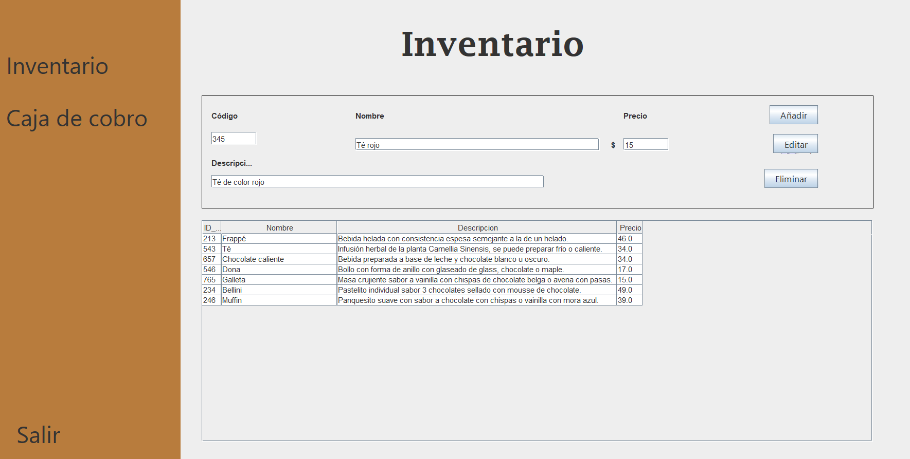

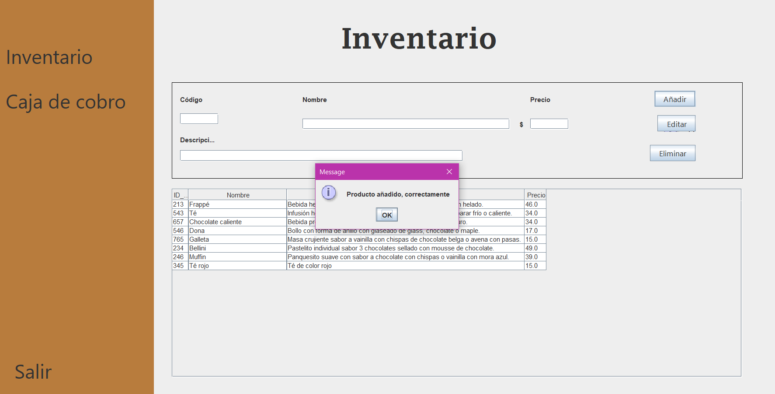

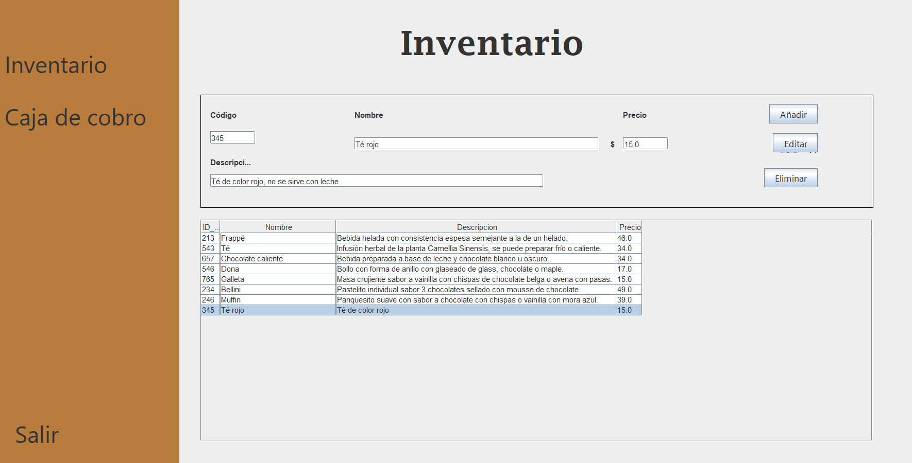

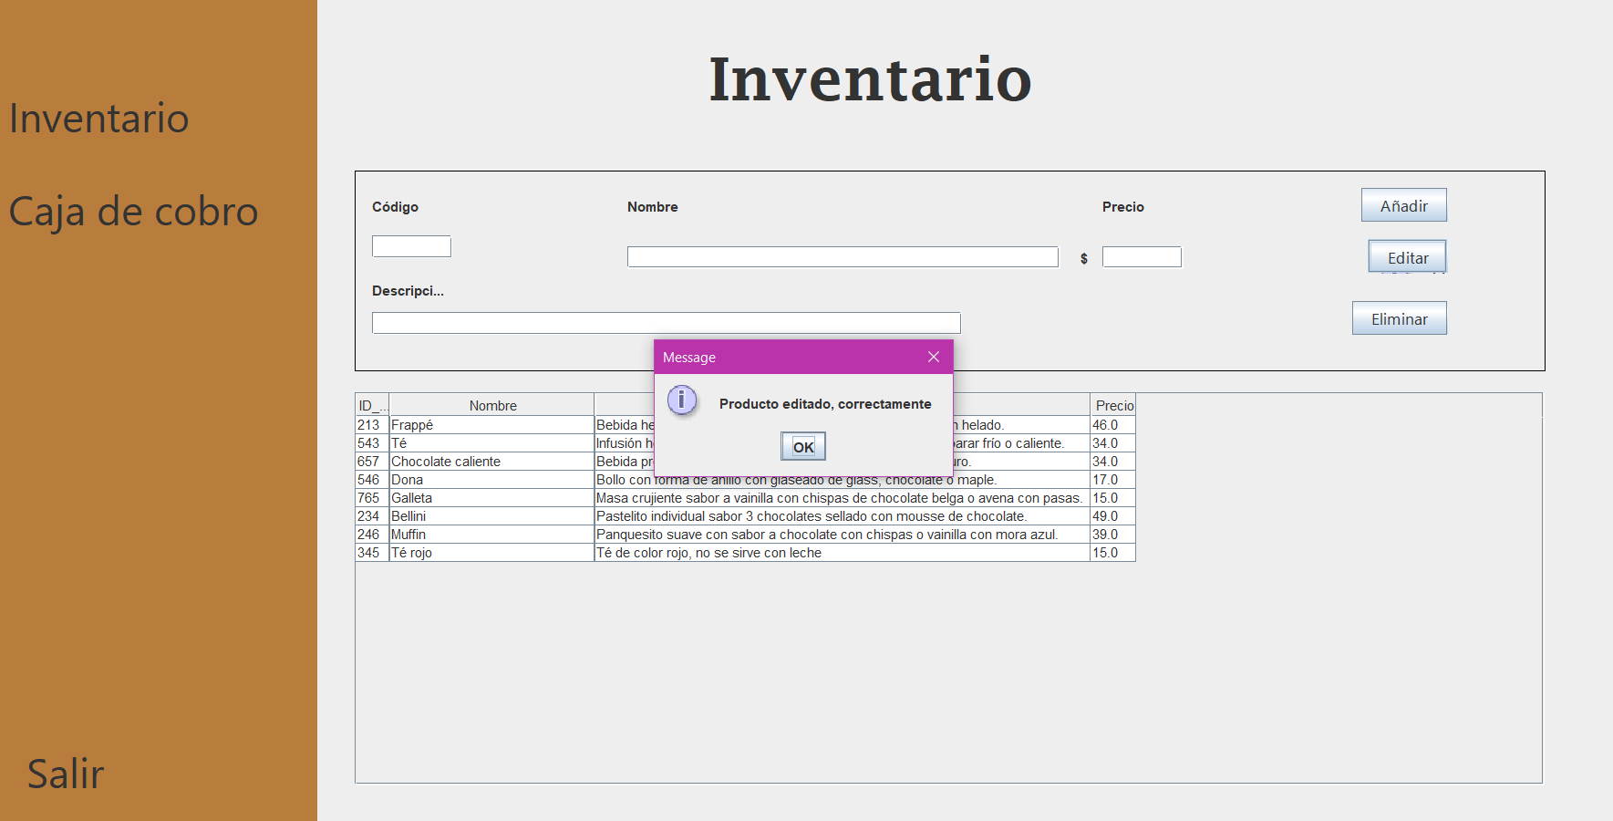

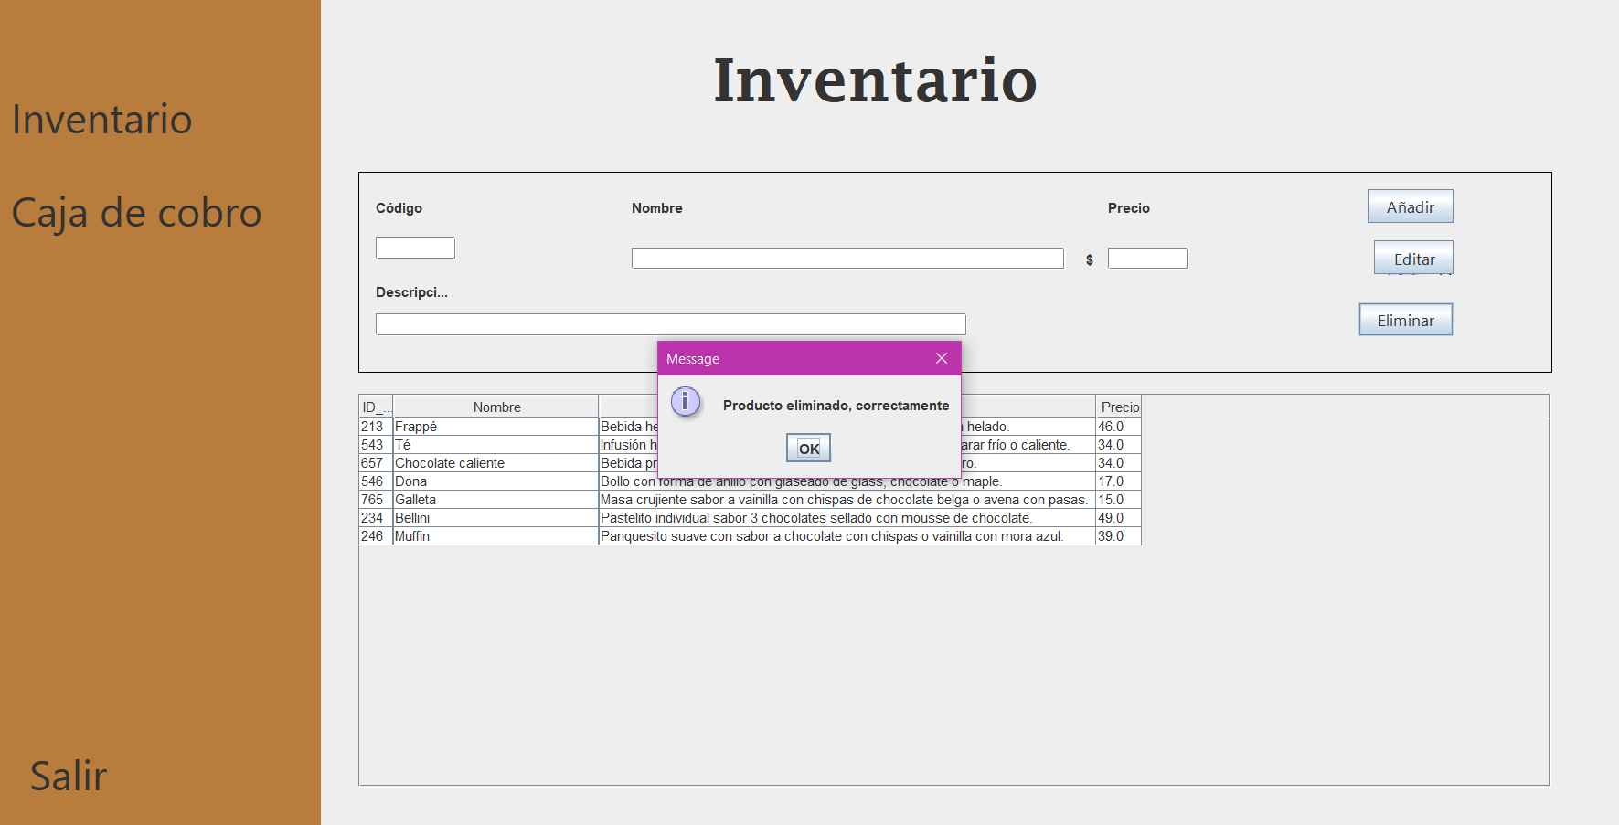

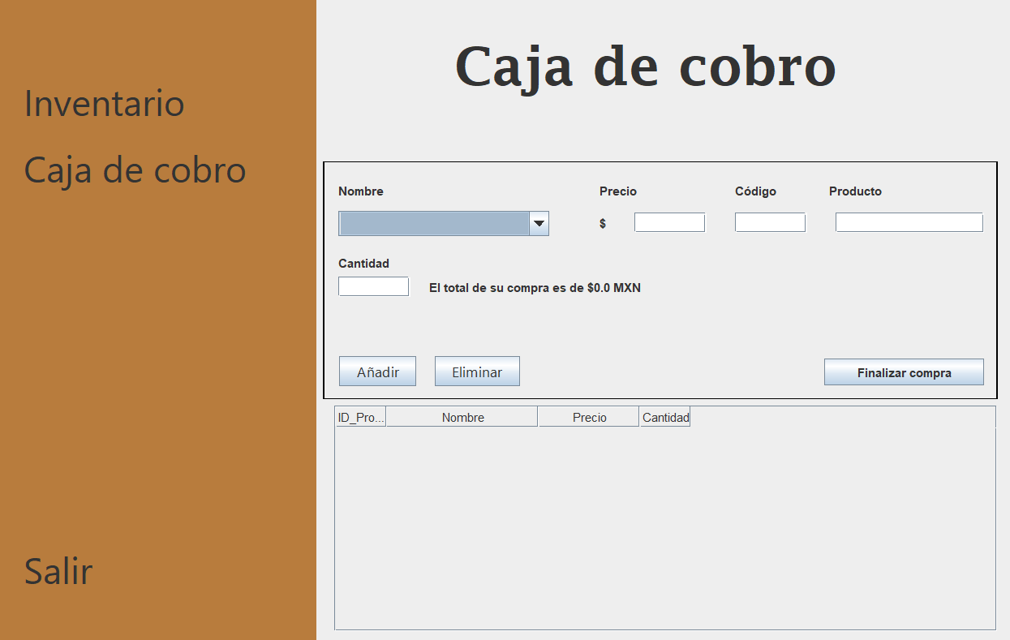

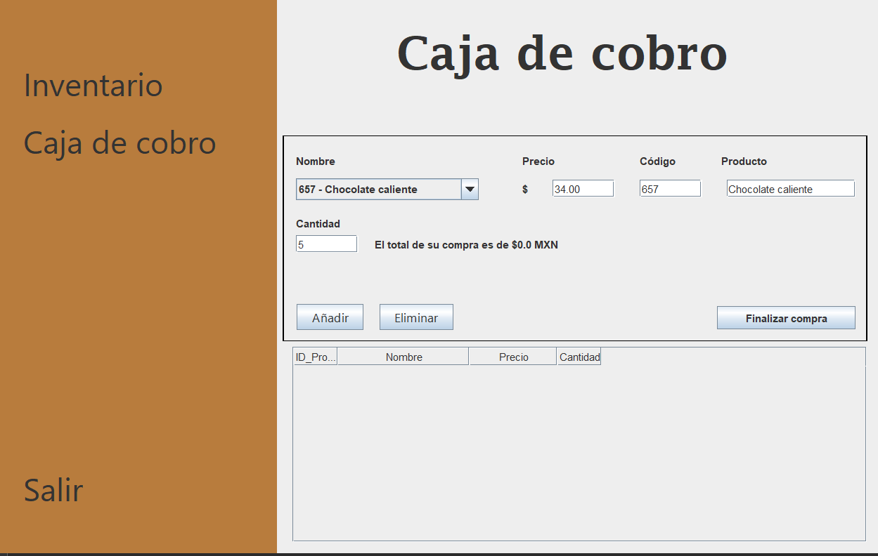

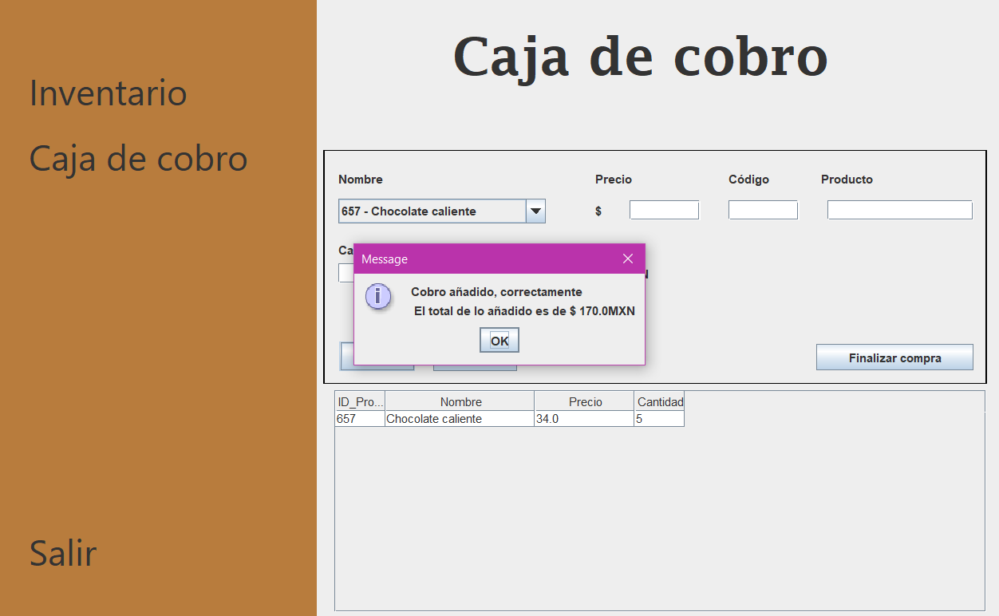

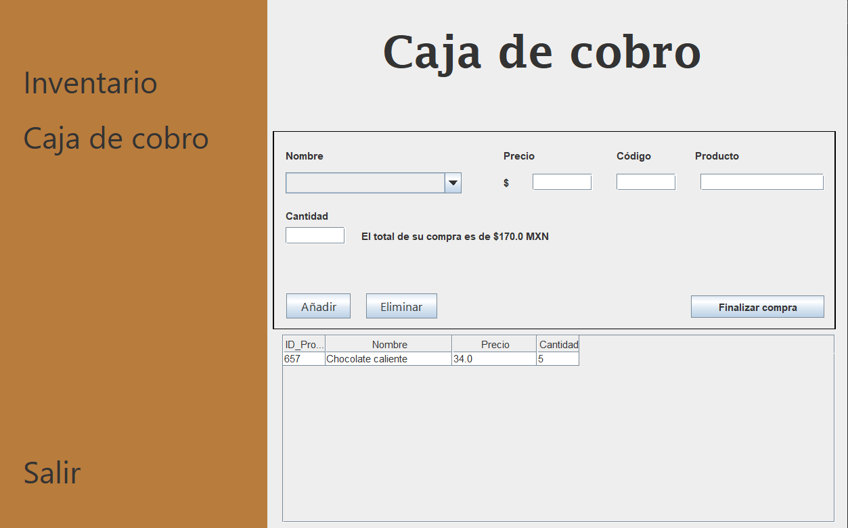

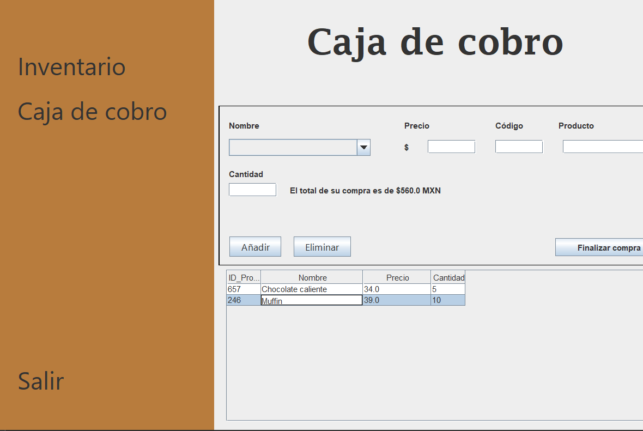

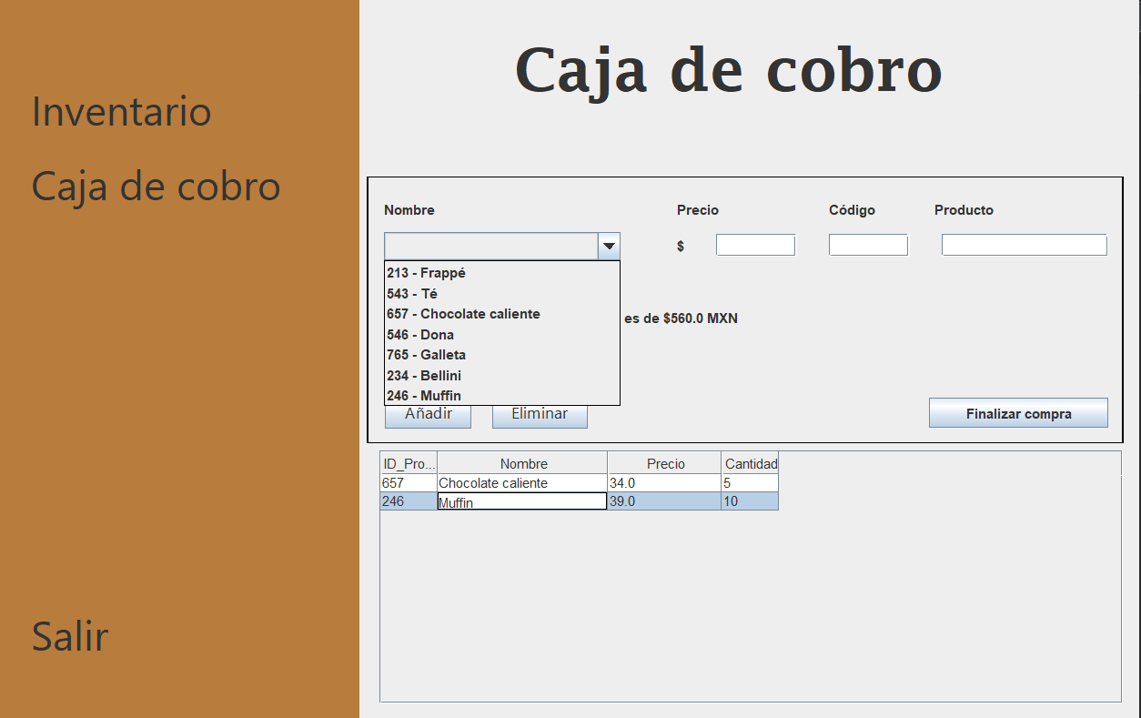

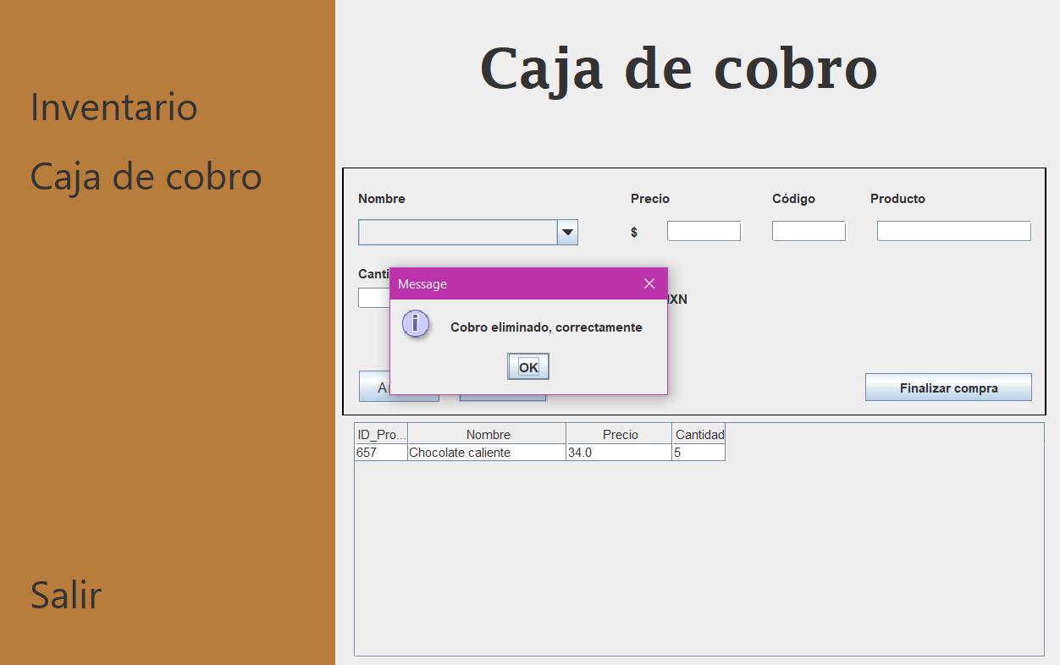

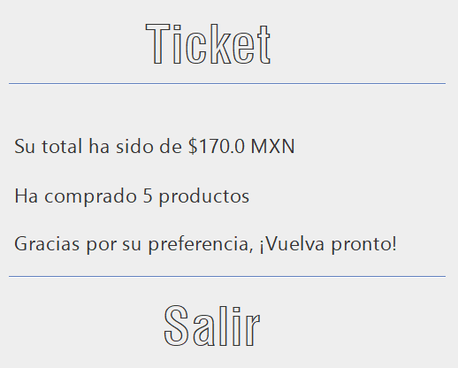

# Código fuente

# CajaDeCobro.java

|  |
| --- |
| package xocotepetl;  import java.awt.Component;  import java.sql.Connection;  import java.sql.Statement;  import java.sql.ResultSet;  import java.sql.SQLException;  import javax.swing.JOptionPane;  import javax.swing.JTable;  import javax.swing.table.DefaultTableModel;  import javax.swing.table.TableCellRenderer;  import javax.swing.table.TableColumn;  public class CajaDeCobro extends javax.swing.JFrame {  public CajaDeCobro() {  initComponents();  comboProducto();  mostrar();  }    private void comboProducto(){  try {  Connection con = Conexion_interac.getConexion();  Statement st = con.createStatement();  ResultSet rs = st.executeQuery("SELECT ID_Producto, Nombre FROM chocolateria");  while (rs.next()) {  listadoProductos.addItem(rs.getString("ID_Producto") + " - " + rs.getString("Nombre"));  }  listadoProductos.setSelectedIndex(-1);    } catch (Exception e) {  System.out.println(e.getMessage());  }  codigoproducto.setText("");  productomostrado.setText("");  precioproducto.setText("");  }      private static double calcularTotalVentas() {  double totalVentas = 0.0;  try {  Connection con = Conexion_interac.getConexion();  Statement st = con.createStatement();  ResultSet rs = st.executeQuery("SELECT SUM(Cantidad * Precio) AS TotalVentas FROM ventas");  if (rs.next()) {  totalVentas = rs.getDouble("TotalVentas");  }  } catch (SQLException e) {  System.out.println(e);  }  return totalVentas;  }    private void mostrar() {  tablaventas.setAutoResizeMode(JTable.AUTO_RESIZE_OFF);  for (int column = 0; column < tablaventas.getColumnCount(); column++)  {  TableColumn tableColumn = tablaventas.getColumnModel().getColumn(column);  int preferredWidth = tableColumn.getMinWidth();  int maxWidth = tableColumn.getMaxWidth();  for (int row = 0; row < tablaventas.getRowCount(); row++)  {  TableCellRenderer cellRenderer = tablaventas.getCellRenderer(row, column);  Component c = tablaventas.prepareRenderer(cellRenderer, row, column);  int width = c.getPreferredSize().width + tablaventas.getIntercellSpacing().width;  preferredWidth = Math.max(preferredWidth, width);  if (preferredWidth >= maxWidth)  {  preferredWidth = maxWidth;  break;  }  }  tableColumn.setPreferredWidth(preferredWidth);  }  DefaultTableModel modelo = new DefaultTableModel();  modelo.setColumnIdentifiers(new String[]{"ID_Producto", "Nombre", "Precio", "Cantidad"});    try {  Connection con = Conexion_interac.getConexion();  Statement st = con.createStatement();  ResultSet rs = st.executeQuery("SELECT ID_Producto, Nombre, Precio, Cantidad FROM Ventas");    while (rs.next()) {  Object[] fila = new Object[4];  fila[0] = rs.getInt("ID_Producto");  fila[1] = rs.getString("Nombre");  fila[2] = rs.getDouble("Precio");  fila[3] = rs.getInt("Cantidad");  modelo.addRow(fila);  }    tablaventas.setModel(modelo);  tablaventas.getColumnModel().getColumn(0).setPreferredWidth(50);  tablaventas.getColumnModel().getColumn(1).setPreferredWidth(150);  tablaventas.getColumnModel().getColumn(2).setPreferredWidth(100);  tablaventas.getColumnModel().getColumn(3).setPreferredWidth(50);    } catch (Exception e) {  System.out.println(e);  }  }    @SuppressWarnings("unchecked")  // <editor-fold defaultstate="collapsed" desc="Generated Code">  private void initComponents() {  jPanel1 = new javax.swing.JPanel();  jLabel1 = new javax.swing.JLabel();  jLabel2 = new javax.swing.JLabel();  jLabel4 = new javax.swing.JLabel();  jLabel5 = new javax.swing.JLabel();  jLabel6 = new javax.swing.JLabel();  jPanel2 = new javax.swing.JPanel();  addproduct = new javax.swing.JButton();  rmvproduct = new javax.swing.JButton();  jLabel7 = new javax.swing.JLabel();  jLabel8 = new javax.swing.JLabel();  jLabel9 = new javax.swing.JLabel();  jLabel10 = new javax.swing.JLabel();  jLabel11 = new javax.swing.JLabel();  codigoproducto = new javax.swing.JTextField();  productomostrado = new javax.swing.JTextField();  jLabel13 = new javax.swing.JLabel();  cantidad = new javax.swing.JTextField();  listadoProductos = new javax.swing.JComboBox<>();  lblsubtotal = new javax.swing.JLabel();  cerrarcuenta = new javax.swing.JButton();  precioproducto = new javax.swing.JTextField();  jScrollPane1 = new javax.swing.JScrollPane();  tablaventas = new javax.swing.JTable();  setDefaultCloseOperation(javax.swing.WindowConstants.EXIT_ON_CLOSE);  setUndecorated(true);  jPanel1.setBackground(new java.awt.Color(184, 124, 61));  jLabel1.setFont(new java.awt.Font("Segoe UI", 0, 36)); // NOI18N  jLabel1.setText("Inventario");  jLabel1.addMouseListener(new java.awt.event.MouseAdapter() {  public void mouseClicked(java.awt.event.MouseEvent evt) {  jLabel1MouseClicked(evt);  }  });  jLabel2.setFont(new java.awt.Font("Segoe UI", 0, 36)); // NOI18N  jLabel2.setText("Salir");  jLabel2.addMouseListener(new java.awt.event.MouseAdapter() {  public void mouseClicked(java.awt.event.MouseEvent evt) {  jLabel2MouseClicked(evt);  }  public void mouseEntered(java.awt.event.MouseEvent evt) {  jLabel2MouseEntered(evt);  }  });  jLabel4.setFont(new java.awt.Font("Segoe UI", 0, 36)); // NOI18N  jLabel4.setText("Caja de cobro");  jLabel4.addMouseListener(new java.awt.event.MouseAdapter() {  public void mouseClicked(java.awt.event.MouseEvent evt) {  jLabel4MouseClicked(evt);  }  });  javax.swing.GroupLayout jPanel1Layout = new javax.swing.GroupLayout(jPanel1);  jPanel1.setLayout(jPanel1Layout);  jPanel1Layout.setHorizontalGroup(  jPanel1Layout.createParallelGroup(javax.swing.GroupLayout.Alignment.LEADING)  .addGroup(jPanel1Layout.createSequentialGroup()  .addGap(30, 30, 30)  .addGroup(jPanel1Layout.createParallelGroup(javax.swing.GroupLayout.Alignment.LEADING)  .addComponent(jLabel2, javax.swing.GroupLayout.PREFERRED_SIZE, 157, javax.swing.GroupLayout.PREFERRED_SIZE)  .addComponent(jLabel4, javax.swing.GroupLayout.PREFERRED_SIZE, 269, javax.swing.GroupLayout.PREFERRED_SIZE)  .addComponent(jLabel1, javax.swing.GroupLayout.PREFERRED_SIZE, 186, javax.swing.GroupLayout.PREFERRED_SIZE))  .addContainerGap(20, Short.MAX_VALUE))  );  jPanel1Layout.setVerticalGroup(  jPanel1Layout.createParallelGroup(javax.swing.GroupLayout.Alignment.LEADING)  .addGroup(jPanel1Layout.createSequentialGroup()  .addGap(75, 75, 75)  .addComponent(jLabel1)  .addGap(18, 18, 18)  .addComponent(jLabel4)  .addPreferredGap(javax.swing.LayoutStyle.ComponentPlacement.RELATED, javax.swing.GroupLayout.DEFAULT_SIZE, Short.MAX_VALUE)  .addComponent(jLabel2)  .addGap(50, 50, 50))  );  jLabel5.setFont(new java.awt.Font("Lucida Fax", 1, 52)); // NOI18N  jLabel5.setHorizontalAlignment(javax.swing.SwingConstants.CENTER);  jLabel5.setText("Caja de cobro");  jPanel2.setBorder(javax.swing.BorderFactory.createLineBorder(new java.awt.Color(0, 0, 0)));  addproduct.setFont(new java.awt.Font("Segoe UI", 0, 14)); // NOI18N  addproduct.setText("Añadir");  addproduct.addActionListener(new java.awt.event.ActionListener() {  public void actionPerformed(java.awt.event.ActionEvent evt) {  addproductActionPerformed(evt);  }  });  rmvproduct.setFont(new java.awt.Font("Segoe UI", 0, 14)); // NOI18N  rmvproduct.setText("Eliminar");  rmvproduct.addActionListener(new java.awt.event.ActionListener() {  public void actionPerformed(java.awt.event.ActionEvent evt) {  rmvproductActionPerformed(evt);  }  });  jLabel7.setText("Código");  jLabel8.setText("Nombre");  jLabel9.setText("Precio");  jLabel10.setText("Producto");  jLabel11.setText("Cantidad");  codigoproducto.addActionListener(new java.awt.event.ActionListener() {  public void actionPerformed(java.awt.event.ActionEvent evt) {  codigoproductoActionPerformed(evt);  }  });  productomostrado.addActionListener(new java.awt.event.ActionListener() {  public void actionPerformed(java.awt.event.ActionEvent evt) {  productomostradoActionPerformed(evt);  }  });  jLabel13.setText("$");  cantidad.addInputMethodListener(new java.awt.event.InputMethodListener() {  public void caretPositionChanged(java.awt.event.InputMethodEvent evt) {  }  public void inputMethodTextChanged(java.awt.event.InputMethodEvent evt) {  cantidadInputMethodTextChanged(evt);  }  });  cantidad.addActionListener(new java.awt.event.ActionListener() {  public void actionPerformed(java.awt.event.ActionEvent evt) {  cantidadActionPerformed(evt);  }  });  listadoProductos.addItemListener(new java.awt.event.ItemListener() {  public void itemStateChanged(java.awt.event.ItemEvent evt) {  listadoProductosItemStateChanged(evt);  }  });  listadoProductos.addActionListener(new java.awt.event.ActionListener() {  public void actionPerformed(java.awt.event.ActionEvent evt) {  listadoProductosActionPerformed(evt);  }  });  lblsubtotal.setText("El total de su compra es de $0.0 MXN");  cerrarcuenta.setText("Finalizar compra");  cerrarcuenta.setToolTipText("");  cerrarcuenta.addActionListener(new java.awt.event.ActionListener() {  public void actionPerformed(java.awt.event.ActionEvent evt) {  cerrarcuentaActionPerformed(evt);  }  });  javax.swing.GroupLayout jPanel2Layout = new javax.swing.GroupLayout(jPanel2);  jPanel2.setLayout(jPanel2Layout);  jPanel2Layout.setHorizontalGroup(  jPanel2Layout.createParallelGroup(javax.swing.GroupLayout.Alignment.LEADING)  .addGroup(jPanel2Layout.createSequentialGroup()  .addGap(14, 14, 14)  .addGroup(jPanel2Layout.createParallelGroup(javax.swing.GroupLayout.Alignment.LEADING)  .addGroup(jPanel2Layout.createSequentialGroup()  .addComponent(cantidad, javax.swing.GroupLayout.PREFERRED_SIZE, 71, javax.swing.GroupLayout.PREFERRED_SIZE)  .addGap(18, 18, 18)  .addComponent(lblsubtotal, javax.swing.GroupLayout.PREFERRED_SIZE, 347, javax.swing.GroupLayout.PREFERRED_SIZE))  .addGroup(javax.swing.GroupLayout.Alignment.TRAILING, jPanel2Layout.createSequentialGroup()  .addGap(0, 0, Short.MAX_VALUE)  .addGroup(jPanel2Layout.createParallelGroup(javax.swing.GroupLayout.Alignment.LEADING)  .addGroup(javax.swing.GroupLayout.Alignment.TRAILING, jPanel2Layout.createSequentialGroup()  .addComponent(addproduct)  .addGap(18, 18, 18)  .addComponent(rmvproduct)  .addGap(300, 300, 300)  .addComponent(cerrarcuenta, javax.swing.GroupLayout.PREFERRED_SIZE, 158, javax.swing.GroupLayout.PREFERRED_SIZE))  .addGroup(javax.swing.GroupLayout.Alignment.TRAILING, jPanel2Layout.createSequentialGroup()  .addGroup(jPanel2Layout.createParallelGroup(javax.swing.GroupLayout.Alignment.LEADING)  .addGroup(javax.swing.GroupLayout.Alignment.TRAILING, jPanel2Layout.createSequentialGroup()  .addComponent(jLabel8, javax.swing.GroupLayout.PREFERRED_SIZE, 65, javax.swing.GroupLayout.PREFERRED_SIZE)  .addGap(192, 192, 192))  .addGroup(javax.swing.GroupLayout.Alignment.TRAILING, jPanel2Layout.createSequentialGroup()  .addGroup(jPanel2Layout.createParallelGroup(javax.swing.GroupLayout.Alignment.LEADING)  .addComponent(listadoProductos, javax.swing.GroupLayout.PREFERRED_SIZE, 208, javax.swing.GroupLayout.PREFERRED_SIZE)  .addComponent(jLabel11, javax.swing.GroupLayout.PREFERRED_SIZE, 79, javax.swing.GroupLayout.PREFERRED_SIZE))  .addGap(49, 49, 49)))  .addGroup(jPanel2Layout.createParallelGroup(javax.swing.GroupLayout.Alignment.LEADING)  .addComponent(jLabel9, javax.swing.GroupLayout.PREFERRED_SIZE, 65, javax.swing.GroupLayout.PREFERRED_SIZE)  .addGroup(jPanel2Layout.createSequentialGroup()  .addComponent(jLabel13, javax.swing.GroupLayout.PREFERRED_SIZE, 17, javax.swing.GroupLayout.PREFERRED_SIZE)  .addPreferredGap(javax.swing.LayoutStyle.ComponentPlacement.UNRELATED)  .addComponent(precioproducto, javax.swing.GroupLayout.PREFERRED_SIZE, 71, javax.swing.GroupLayout.PREFERRED_SIZE)))  .addGap(28, 28, 28)  .addGroup(jPanel2Layout.createParallelGroup(javax.swing.GroupLayout.Alignment.LEADING)  .addComponent(jLabel7, javax.swing.GroupLayout.PREFERRED_SIZE, 65, javax.swing.GroupLayout.PREFERRED_SIZE)  .addComponent(codigoproducto, javax.swing.GroupLayout.PREFERRED_SIZE, 71, javax.swing.GroupLayout.PREFERRED_SIZE))  .addGap(22, 22, 22)  .addGroup(jPanel2Layout.createParallelGroup(javax.swing.GroupLayout.Alignment.LEADING)  .addGroup(jPanel2Layout.createSequentialGroup()  .addGap(6, 6, 6)  .addComponent(productomostrado, javax.swing.GroupLayout.PREFERRED_SIZE, 147, javax.swing.GroupLayout.PREFERRED_SIZE))  .addComponent(jLabel10, javax.swing.GroupLayout.PREFERRED_SIZE, 65, javax.swing.GroupLayout.PREFERRED_SIZE))))))  .addContainerGap(javax.swing.GroupLayout.DEFAULT_SIZE, Short.MAX_VALUE))  );  jPanel2Layout.setVerticalGroup(  jPanel2Layout.createParallelGroup(javax.swing.GroupLayout.Alignment.LEADING)  .addGroup(jPanel2Layout.createSequentialGroup()  .addGap(20, 20, 20)  .addGroup(jPanel2Layout.createParallelGroup(javax.swing.GroupLayout.Alignment.BASELINE)  .addComponent(jLabel10)  .addComponent(jLabel8)  .addComponent(jLabel7)  .addComponent(jLabel9))  .addPreferredGap(javax.swing.LayoutStyle.ComponentPlacement.UNRELATED)  .addGroup(jPanel2Layout.createParallelGroup(javax.swing.GroupLayout.Alignment.BASELINE)  .addComponent(productomostrado, javax.swing.GroupLayout.PREFERRED_SIZE, javax.swing.GroupLayout.DEFAULT_SIZE, javax.swing.GroupLayout.PREFERRED_SIZE)  .addComponent(codigoproducto, javax.swing.GroupLayout.PREFERRED_SIZE, javax.swing.GroupLayout.DEFAULT_SIZE, javax.swing.GroupLayout.PREFERRED_SIZE)  .addComponent(listadoProductos, javax.swing.GroupLayout.PREFERRED_SIZE, javax.swing.GroupLayout.DEFAULT_SIZE, javax.swing.GroupLayout.PREFERRED_SIZE)  .addComponent(precioproducto, javax.swing.GroupLayout.PREFERRED_SIZE, javax.swing.GroupLayout.DEFAULT_SIZE, javax.swing.GroupLayout.PREFERRED_SIZE)  .addComponent(jLabel13))  .addGap(18, 18, 18)  .addComponent(jLabel11)  .addPreferredGap(javax.swing.LayoutStyle.ComponentPlacement.RELATED)  .addGroup(jPanel2Layout.createParallelGroup(javax.swing.GroupLayout.Alignment.BASELINE)  .addComponent(cantidad, javax.swing.GroupLayout.PREFERRED_SIZE, javax.swing.GroupLayout.DEFAULT_SIZE, javax.swing.GroupLayout.PREFERRED_SIZE)  .addComponent(lblsubtotal))  .addPreferredGap(javax.swing.LayoutStyle.ComponentPlacement.RELATED, 58, Short.MAX_VALUE)  .addGroup(jPanel2Layout.createParallelGroup(javax.swing.GroupLayout.Alignment.BASELINE)  .addComponent(addproduct)  .addComponent(rmvproduct)  .addComponent(cerrarcuenta))  .addContainerGap())  );  tablaventas.addMouseListener(new java.awt.event.MouseAdapter() {  public void mouseClicked(java.awt.event.MouseEvent evt) {  tablaventasMouseClicked(evt);  }  });  jScrollPane1.setViewportView(tablaventas);  javax.swing.GroupLayout layout = new javax.swing.GroupLayout(getContentPane());  getContentPane().setLayout(layout);  layout.setHorizontalGroup(  layout.createParallelGroup(javax.swing.GroupLayout.Alignment.LEADING)  .addGroup(layout.createSequentialGroup()  .addComponent(jPanel1, javax.swing.GroupLayout.PREFERRED_SIZE, javax.swing.GroupLayout.DEFAULT_SIZE, javax.swing.GroupLayout.PREFERRED_SIZE)  .addGroup(layout.createParallelGroup(javax.swing.GroupLayout.Alignment.LEADING)  .addGroup(layout.createSequentialGroup()  .addPreferredGap(javax.swing.LayoutStyle.ComponentPlacement.RELATED, javax.swing.GroupLayout.DEFAULT_SIZE, Short.MAX_VALUE)  .addComponent(jScrollPane1, javax.swing.GroupLayout.PREFERRED_SIZE, 654, javax.swing.GroupLayout.PREFERRED_SIZE))  .addGroup(layout.createSequentialGroup()  .addGap(26, 26, 26)  .addComponent(jLabel6, javax.swing.GroupLayout.PREFERRED_SIZE, 37, javax.swing.GroupLayout.PREFERRED_SIZE))  .addGroup(layout.createSequentialGroup()  .addGap(7, 7, 7)  .addComponent(jPanel2, javax.swing.GroupLayout.PREFERRED_SIZE, javax.swing.GroupLayout.DEFAULT_SIZE, javax.swing.GroupLayout.PREFERRED_SIZE))  .addGroup(layout.createSequentialGroup()  .addGap(124, 124, 124)  .addComponent(jLabel5, javax.swing.GroupLayout.PREFERRED_SIZE, 402, javax.swing.GroupLayout.PREFERRED_SIZE)))  .addContainerGap(14, Short.MAX_VALUE))  );  layout.setVerticalGroup(  layout.createParallelGroup(javax.swing.GroupLayout.Alignment.LEADING)  .addGroup(layout.createSequentialGroup()  .addGap(33, 33, 33)  .addComponent(jLabel5)  .addGap(58, 58, 58)  .addComponent(jLabel6)  .addPreferredGap(javax.swing.LayoutStyle.ComponentPlacement.RELATED)  .addComponent(jPanel2, javax.swing.GroupLayout.PREFERRED_SIZE, javax.swing.GroupLayout.DEFAULT_SIZE, javax.swing.GroupLayout.PREFERRED_SIZE)  .addPreferredGap(javax.swing.LayoutStyle.ComponentPlacement.RELATED)  .addComponent(jScrollPane1, javax.swing.GroupLayout.PREFERRED_SIZE, 223, javax.swing.GroupLayout.PREFERRED_SIZE)  .addGap(6, 12, Short.MAX_VALUE))  .addComponent(jPanel1, javax.swing.GroupLayout.Alignment.TRAILING, javax.swing.GroupLayout.DEFAULT_SIZE, javax.swing.GroupLayout.DEFAULT_SIZE, Short.MAX_VALUE)  );  pack();  setLocationRelativeTo(null);  }// </editor-fold>  private void addproductActionPerformed(java.awt.event.ActionEvent evt) {  // TODO add your handling code here:  String vCodigoProducto = codigoproducto.getText();  String vIngredienteProducto = productomostrado.getText();  String vPrecio = precioproducto.getText();  String vCantidad = cantidad.getText();  int intcantidad = Integer.parseInt(vCantidad);  Double precio = Double.valueOf(vPrecio);    try {  Connection con = Conexion_interac.getConexion();  Statement st = con.createStatement();  st.execute("INSERT INTO ventas (ID_Producto, Nombre, Precio, Cantidad) "  + "values(" + vCodigoProducto + ",'" + vIngredienteProducto + "', "  + vPrecio + "," + vCantidad + ")");    codigoproducto.setText("");  productomostrado.setText("");  precioproducto.setText("");  cantidad.setText("");  mostrar();    lblsubtotal.setText("El total de su compra es de $" + calcularTotalVentas() + " MXN");  JOptionPane.showMessageDialog(null, "Cobro añadido, correctamente"  + " \n El total de lo añadido es de $ " + intcantidad*precio + "MXN");      } catch (Exception e) {  System.out.println(e);  }  listadoProductos.setSelectedIndex(-1);    }  private void jLabel2MouseEntered(java.awt.event.MouseEvent evt) {  }  private void jLabel2MouseClicked(java.awt.event.MouseEvent evt) {    try {    Connection con = Conexion_interac.getConexion();  Statement st = con.createStatement();  ResultSet resultadoDeConteo = st.executeQuery("select count(*) as count from ventas");  resultadoDeConteo.next();    int count = resultadoDeConteo.getInt("count");    if (count > 0) {  st.executeUpdate("delete from ventas");  System.out.println(count + " registros eliminados de la tabla ventas.");  } else {  System.out.println("No existen registros en la tabla ventas.");  }    } catch (Exception e) {  System.out.println("\nAlgo ha fallado: " + e.getMessage());  }  System.exit(0);  }  private void jLabel4MouseClicked(java.awt.event.MouseEvent evt) {  // TODO add your handling code here:    }  private void jLabel1MouseClicked(java.awt.event.MouseEvent evt) {  // TODO add your handling code here:  Inventario inv = new Inventario();  this.hide();  inv.setVisible(true);  }  private void cantidadActionPerformed(java.awt.event.ActionEvent evt) {    }  private void listadoProductosItemStateChanged(java.awt.event.ItemEvent evt) {    }  private void listadoProductosActionPerformed(java.awt.event.ActionEvent evt) {    String selectedProduct = listadoProductos.getSelectedItem().toString();  String[] datosProducto = selectedProduct.split(" - ");  String selectedProductId = datosProducto[0];  try {  Connection con = Conexion_interac.getConexion();  Statement st = con.createStatement();  ResultSet rs = st.executeQuery("SELECT Precio FROM chocolateria WHERE ID_Producto = " + selectedProductId);  if (rs.next()) {  String precio = rs.getString("Precio");    precioproducto.setText(precio);  }  } catch (Exception e) {  System.out.println(e.getMessage());  }  codigoproducto.setText(datosProducto[0]);  productomostrado.setText(datosProducto[1]);  }  private void rmvproductActionPerformed(java.awt.event.ActionEvent evt) {    String vCodigoProducto = tablaventas.getValueAt(tablaventas.getSelectedRow(),0).toString();  String vIngredienteProducto = tablaventas.getValueAt(tablaventas.getSelectedRow(),1).toString();  String vPrecio = tablaventas.getValueAt(tablaventas.getSelectedRow(),2).toString();    try {  Connection con = Conexion_interac.getConexion();  Statement st = con.createStatement();  st.execute("DELETE FROM ventas WHERE ID_Producto = " + vCodigoProducto + " AND "  + "Nombre = '" + vIngredienteProducto + "' AND "  + "Precio = " + vPrecio);    mostrar();  lblsubtotal.setText("El total de su compra es de $" + calcularTotalVentas() + " MXN");  JOptionPane.showMessageDialog(null, "Cobro eliminado, correctamente");  } catch (Exception e) {  System.out.println(e);  }  listadoProductos.setSelectedIndex(-1);  }  private void cantidadInputMethodTextChanged(java.awt.event.InputMethodEvent evt) {      }  private void productomostradoActionPerformed(java.awt.event.ActionEvent evt) {    }  private void cerrarcuentaActionPerformed(java.awt.event.ActionEvent evt) {  Ticket ticket = new Ticket();  this.hide();  ticket.setVisible(true);    }  private void codigoproductoActionPerformed(java.awt.event.ActionEvent evt) {  }  private void tablaventasMouseClicked(java.awt.event.MouseEvent evt) {    if (evt.getClickCount() == 2) {  int vFilaSeleccionada = tablaventas.getSelectedRow();  codigoproducto.setText(tablaventas.getValueAt(vFilaSeleccionada, 0).toString());  productomostrado.setText(tablaventas.getValueAt(vFilaSeleccionada, 1).toString());  precioproducto.setText(tablaventas.getValueAt(vFilaSeleccionada, 2).toString());  cantidad.setText(tablaventas.getValueAt(vFilaSeleccionada, 3).toString());  }  }  public static void main(String args[]) {    java.awt.EventQueue.invokeLater(new Runnable() {  public void run() {  new CajaDeCobro().setVisible(true);  }  });  }  // Variables declaration - do not modify  private javax.swing.JButton addproduct;  private javax.swing.JTextField cantidad;  private javax.swing.JButton cerrarcuenta;  private javax.swing.JTextField codigoproducto;  private javax.swing.JLabel jLabel1;  private javax.swing.JLabel jLabel10;  private javax.swing.JLabel jLabel11;  private javax.swing.JLabel jLabel13;  private javax.swing.JLabel jLabel2;  private javax.swing.JLabel jLabel4;  private javax.swing.JLabel jLabel5;  private javax.swing.JLabel jLabel6;  private javax.swing.JLabel jLabel7;  private javax.swing.JLabel jLabel8;  private javax.swing.JLabel jLabel9;  private javax.swing.JPanel jPanel1;  private javax.swing.JPanel jPanel2;  private javax.swing.JScrollPane jScrollPane1;  private javax.swing.JLabel lblsubtotal;  private javax.swing.JComboBox<String> listadoProductos;  private javax.swing.JTextField precioproducto;  private javax.swing.JTextField productomostrado;  private javax.swing.JButton rmvproduct;  private javax.swing.JTable tablaventas;  // End of variables declaration  } |

# Xocotepetl.java

|  |
| --- |
| package xocotepetl;  public class Xocotepetl {  public static void main(String[] args) {  Inventario in = new Inventario();  in.setVisible(true);  }  } |

# Ticket.java

|  |
| --- |
| package xocotepetl;  import java.awt.Dimension;  import java.awt.Toolkit;  import java.sql.Connection;  import java.sql.Statement;  import java.sql.ResultSet;  import java.sql.SQLException;  public final class Ticket extends javax.swing.JFrame {  public Ticket() {  initComponents();    centrarPantalla();    System.out.println("El total de ventas es: " + calcularTotalVentas() + "\nha comprado " +contarProductosVendidos());    lblPrecio.setText("Su total ha sido de $" + calcularTotalVentas() + " MXN");  lblProductosComprados.setText("\nHa comprado " + contarProductosVendidos() + " productos");  }    private void centrarPantalla(){  Dimension pantalla = Toolkit.getDefaultToolkit().getScreenSize();  Dimension ventana = this.getSize();  int posX = (pantalla.width - ventana.width) /2;  int posY = (pantalla.height - ventana.height)/2;  this.setLocation(posX, posY);  }    private static double calcularTotalVentas() {  double totalVentas = 0.0;  try {  Connection con = Conexion_interac.getConexion();  Statement st = con.createStatement();  ResultSet rs = st.executeQuery("SELECT SUM(Cantidad * Precio) AS TotalVentas FROM ventas");  if (rs.next()) {  totalVentas = rs.getDouble("TotalVentas");  }  } catch (SQLException e) {  System.out.println(e);  }  return totalVentas;  }    private static int contarProductosVendidos() {  int numProductosVendidos = 0;  try {  Connection con = Conexion_interac.getConexion();  Statement st = con.createStatement();  ResultSet rs = st.executeQuery("SELECT SUM(Cantidad) AS NumProductosVendidos FROM ventas");  if (rs.next()) {  numProductosVendidos = rs.getInt("NumProductosVendidos");  }  } catch (SQLException e) {  System.out.println(e);  }  return numProductosVendidos;  }    @SuppressWarnings("unchecked")  // <editor-fold defaultstate="collapsed" desc="Generated Code">  private void initComponents() {  jLabel1 = new javax.swing.JLabel();  jSeparator1 = new javax.swing.JSeparator();  jLabel2 = new javax.swing.JLabel();  jSeparator2 = new javax.swing.JSeparator();  lblPrecio = new javax.swing.JLabel();  lblSalida = new javax.swing.JLabel();  lblProductosComprados = new javax.swing.JLabel();  setTitle("Total");  setAlwaysOnTop(true);  setLocation(new java.awt.Point(0, 0));  setUndecorated(true);  jLabel1.setFont(new java.awt.Font("Swis721 BdCnOul BT", 0, 48)); // NOI18N  jLabel1.setText("Salir");  jLabel1.addMouseListener(new java.awt.event.MouseAdapter() {  public void mouseClicked(java.awt.event.MouseEvent evt) {  jLabel1MouseClicked(evt);  }  });  jLabel2.setFont(new java.awt.Font("Swis721 BdCnOul BT", 0, 48)); // NOI18N  jLabel2.setText("Ticket");  lblPrecio.setFont(new java.awt.Font("Segoe UI Historic", 0, 18)); // NOI18N  lblPrecio.setText("Costo");  lblSalida.setFont(new java.awt.Font("Segoe UI Historic", 0, 18)); // NOI18N  lblSalida.setText("Gracias por su preferencia, ¡Vuelva pronto!");  lblProductosComprados.setFont(new java.awt.Font("Segoe UI Historic", 0, 18)); // NOI18N  lblProductosComprados.setText("Total");  javax.swing.GroupLayout layout = new javax.swing.GroupLayout(getContentPane());  getContentPane().setLayout(layout);  layout.setHorizontalGroup(  layout.createParallelGroup(javax.swing.GroupLayout.Alignment.LEADING)  .addGroup(layout.createSequentialGroup()  .addGroup(layout.createParallelGroup(javax.swing.GroupLayout.Alignment.LEADING)  .addGroup(layout.createSequentialGroup()  .addContainerGap()  .addGroup(layout.createParallelGroup(javax.swing.GroupLayout.Alignment.LEADING)  .addComponent(jSeparator1, javax.swing.GroupLayout.PREFERRED_SIZE, 395, javax.swing.GroupLayout.PREFERRED_SIZE)  .addComponent(jSeparator2, javax.swing.GroupLayout.PREFERRED_SIZE, 395, javax.swing.GroupLayout.PREFERRED_SIZE)))  .addGroup(layout.createSequentialGroup()  .addGap(17, 17, 17)  .addGroup(layout.createParallelGroup(javax.swing.GroupLayout.Alignment.LEADING, false)  .addComponent(lblPrecio, javax.swing.GroupLayout.DEFAULT_SIZE, javax.swing.GroupLayout.DEFAULT_SIZE, Short.MAX_VALUE)  .addComponent(lblSalida, javax.swing.GroupLayout.DEFAULT_SIZE, 374, Short.MAX_VALUE)  .addComponent(lblProductosComprados, javax.swing.GroupLayout.DEFAULT_SIZE, javax.swing.GroupLayout.DEFAULT_SIZE, Short.MAX_VALUE)))  .addGroup(layout.createSequentialGroup()  .addGap(150, 150, 150)  .addComponent(jLabel1))  .addGroup(layout.createSequentialGroup()  .addGap(135, 135, 135)  .addComponent(jLabel2)))  .addContainerGap(javax.swing.GroupLayout.DEFAULT_SIZE, Short.MAX_VALUE))  );  layout.setVerticalGroup(  layout.createParallelGroup(javax.swing.GroupLayout.Alignment.LEADING)  .addGroup(layout.createSequentialGroup()  .addContainerGap()  .addComponent(jLabel2)  .addPreferredGap(javax.swing.LayoutStyle.ComponentPlacement.RELATED)  .addComponent(jSeparator1, javax.swing.GroupLayout.PREFERRED_SIZE, 10, javax.swing.GroupLayout.PREFERRED_SIZE)  .addGap(33, 33, 33)  .addComponent(lblPrecio)  .addPreferredGap(javax.swing.LayoutStyle.ComponentPlacement.RELATED, 20, Short.MAX_VALUE)  .addComponent(lblProductosComprados)  .addGap(18, 18, 18)  .addComponent(lblSalida)  .addGap(18, 18, 18)  .addComponent(jSeparator2, javax.swing.GroupLayout.PREFERRED_SIZE, 10, javax.swing.GroupLayout.PREFERRED_SIZE)  .addPreferredGap(javax.swing.LayoutStyle.ComponentPlacement.RELATED)  .addComponent(jLabel1)  .addContainerGap())  );  pack();  }// </editor-fold>  private void jLabel1MouseClicked(java.awt.event.MouseEvent evt) {    try {    Connection con = Conexion_interac.getConexion();  Statement st = con.createStatement();  ResultSet resultadoDeConteo = st.executeQuery("select count(*) as count from ventas");  resultadoDeConteo.next();    int count = resultadoDeConteo.getInt("count");    if (count > 0) {  st.executeUpdate("delete from ventas");  System.out.println("\n"+count + " registros eliminados de la tabla ventas.");  } else {  System.out.println("\nNo existen registros en la tabla ventas.");  }    } catch (Exception e) {  System.out.println("\nAlgo ha fallado: " + e.getMessage());  }  System.exit(0);  }  public static void main(String args[]) {  try {  for (javax.swing.UIManager.LookAndFeelInfo info : javax.swing.UIManager.getInstalledLookAndFeels()) {  if ("Nimbus".equals(info.getName())) {  javax.swing.UIManager.setLookAndFeel(info.getClassName());  break;  }  }  } catch (ClassNotFoundException ex) {  java.util.logging.Logger.getLogger(Ticket.class.getName()).log(java.util.logging.Level.SEVERE, null, ex);  } catch (InstantiationException ex) {  java.util.logging.Logger.getLogger(Ticket.class.getName()).log(java.util.logging.Level.SEVERE, null, ex);  } catch (IllegalAccessException ex) {  java.util.logging.Logger.getLogger(Ticket.class.getName()).log(java.util.logging.Level.SEVERE, null, ex);  } catch (javax.swing.UnsupportedLookAndFeelException ex) {  java.util.logging.Logger.getLogger(Ticket.class.getName()).log(java.util.logging.Level.SEVERE, null, ex);  }    java.awt.EventQueue.invokeLater(() -> {  new Ticket().setVisible(true);  });  }  // Variables declaration - do not modify  private javax.swing.JLabel jLabel1;  private javax.swing.JLabel jLabel2;  private javax.swing.JSeparator jSeparator1;  private javax.swing.JSeparator jSeparator2;  private javax.swing.JLabel lblPrecio;  private javax.swing.JLabel lblProductosComprados;  private javax.swing.JLabel lblSalida;  // End of variables declaration  } |

# Productos.java

|  |
| --- |
| package xocotepetl;  public class Productos extends DatosInventario {    private int ID_Producto;  private String Nombre;  private String descripcion;  private float precio;  public Productos( int ID_Producto, String Nombre, String descripcion, float precio) {  super( ID_Producto,Nombre, precio);    this.ID_Producto=ID_Producto;  this.Nombre = Nombre;  this.descripcion = descripcion;  this.precio = precio;    }    @Override  public int getIDproducto() {  return ID_Producto;  }    @Override  public void setID_Producto(int ID_Producto) {  this.ID_Producto = ID_Producto;  }      @Override  public String getNombre() {  return Nombre;  }  @Override  public void setNombre(String Nombre) {  this.Nombre = Nombre;  }    public void setDescripcion(String descripcion) {  this.descripcion = descripcion;  }    public String getDescripcion() {  return descripcion;  }  @Override  public float getPrecio() {  return precio;  }  @Override  public void setPrecio(float precio) {  this.precio = precio;  }  } |

## Inventario.java

|  |
| --- |
| package xocotepetl;  import java.awt.Component;  import java.awt.HeadlessException;  import javax.swing.table.DefaultTableModel;  import java.sql.Connection;  import java.sql.ResultSet;  import java.sql.SQLException;  import java.sql.Statement;  import javax.swing.JOptionPane;  import javax.swing.JTable;  import javax.swing.table.TableCellRenderer;  import javax.swing.table.TableColumn;  public class Inventario extends javax.swing.JFrame {  Connection con;    public Inventario() {    this.con = Conexion_interac.getConexion();  System.out.println("Cargando tabla");  initComponents();  mostrar();    }    private void mostrar() {  tabla.setAutoResizeMode(JTable.AUTO_RESIZE_OFF);    for (int column = 0; column < tabla.getColumnCount(); column++)  {  TableColumn tableColumn = tabla.getColumnModel().getColumn(column);  int preferredWidth = tableColumn.getMinWidth();  int maxWidth = tableColumn.getMaxWidth();  for (int row = 0; row < tabla.getRowCount(); row++)  {  TableCellRenderer cellRenderer = tabla.getCellRenderer(row, column);  Component c = tabla.prepareRenderer(cellRenderer, row, column);  int width = c.getPreferredSize().width + tabla.getIntercellSpacing().width;  preferredWidth = Math.max(preferredWidth, width);  if (preferredWidth >= maxWidth)  {  preferredWidth = maxWidth;  break;  }  }  tableColumn.setPreferredWidth(preferredWidth);  }  DefaultTableModel modelo = new DefaultTableModel() {  @Override  public boolean isCellEditable(int row, int column) {  return false;  }  };    modelo.setColumnIdentifiers(new String[]{"ID_Producto", "Nombre", "Descripcion", "Precio"});    try {  Connection con = Conexion_interac.getConexion();  Statement st = con.createStatement();  ResultSet rs = st.executeQuery("SELECT ID_Producto, Nombre, Descripcion, Precio FROM chocolateria");      while (rs.next()) {  Productos filaProducto = new Productos(rs.getInt("ID_Producto"),rs.getString("Nombre"),rs.getString("Descripcion"), rs.getFloat("Precio"));    Object producto[] = {filaProducto.getIDproducto(),filaProducto.getNombre(),filaProducto.getDescripcion(),filaProducto.getPrecio()};    modelo.addRow(producto);  }    tabla.setModel(modelo);  int vAnchoColumna = 0;  int vNuevoAnchoColumna = 0;    for (int col = 0; col < tabla.getColumnCount(); col++) {  vAnchoColumna = 0;  for (int fila = 0; fila < tabla.getRowCount(); fila++) {  if (tabla.getValueAt(fila, col).toString().length() > 47) {  vNuevoAnchoColumna = 435;  } else {  vNuevoAnchoColumna = 10 * tabla.getValueAt(fila, col).toString().length();  }  if (vNuevoAnchoColumna>vAnchoColumna) {  vAnchoColumna = vNuevoAnchoColumna;  } else {  vAnchoColumna = vAnchoColumna;  }  }  tabla.getColumnModel().getColumn(col).setPreferredWidth(vAnchoColumna);    }  tabla.getColumnModel().getColumn(0).setMinWidth(30);  tabla.getColumnModel().getColumn(1).setMinWidth(45);  tabla.getColumnModel().getColumn(2).setMinWidth(60);  tabla.getColumnModel().getColumn(3).setMinWidth(30);    } catch (SQLException e) {  System.out.println(e);    }  }    @SuppressWarnings("unchecked")  // <editor-fold defaultstate="collapsed" desc="Generated Code">  private void initComponents() {  jPanel1 = new javax.swing.JPanel();  jLabel1 = new javax.swing.JLabel();  jLabel2 = new javax.swing.JLabel();  jLabel4 = new javax.swing.JLabel();  jLabel5 = new javax.swing.JLabel();  jLabel6 = new javax.swing.JLabel();  jPanel2 = new javax.swing.JPanel();  addproduct = new javax.swing.JButton();  rmvproduct = new javax.swing.JButton();  editproduct = new javax.swing.JButton();  jLabel8 = new javax.swing.JLabel();  jLabel9 = new javax.swing.JLabel();  jLabel10 = new javax.swing.JLabel();  nombreproducto = new javax.swing.JTextField();  descripcionproducto = new javax.swing.JTextField();  jLabel13 = new javax.swing.JLabel();  precio = new javax.swing.JTextField();  codepr = new javax.swing.JLabel();  ID_Productoin = new javax.swing.JTextField();  jScrollPane1 = new javax.swing.JScrollPane();  tabla = new javax.swing.JTable();  setDefaultCloseOperation(javax.swing.WindowConstants.EXIT_ON_CLOSE);  setUndecorated(true);  jPanel1.setBackground(new java.awt.Color(184, 124, 61));  jLabel1.setFont(new java.awt.Font("Segoe UI", 0, 36)); // NOI18N  jLabel1.setText("Inventario");  jLabel2.setFont(new java.awt.Font("Segoe UI", 0, 36)); // NOI18N  jLabel2.setText("Salir");  jLabel2.addMouseListener(new java.awt.event.MouseAdapter() {  public void mouseClicked(java.awt.event.MouseEvent evt) {  jLabel2MouseClicked(evt);  }  public void mouseEntered(java.awt.event.MouseEvent evt) {  jLabel2MouseEntered(evt);  }  });  jLabel4.setFont(new java.awt.Font("Segoe UI", 0, 36)); // NOI18N  jLabel4.setText("Caja de cobro");  jLabel4.addMouseListener(new java.awt.event.MouseAdapter() {  public void mouseClicked(java.awt.event.MouseEvent evt) {  jLabel4MouseClicked(evt);  }  });  javax.swing.GroupLayout jPanel1Layout = new javax.swing.GroupLayout(jPanel1);  jPanel1.setLayout(jPanel1Layout);  jPanel1Layout.setHorizontalGroup(  jPanel1Layout.createParallelGroup(javax.swing.GroupLayout.Alignment.LEADING)  .addGroup(jPanel1Layout.createSequentialGroup()  .addContainerGap()  .addGroup(jPanel1Layout.createParallelGroup(javax.swing.GroupLayout.Alignment.LEADING)  .addComponent(jLabel4, javax.swing.GroupLayout.PREFERRED_SIZE, 239, javax.swing.GroupLayout.PREFERRED_SIZE)  .addComponent(jLabel1, javax.swing.GroupLayout.PREFERRED_SIZE, 179, javax.swing.GroupLayout.PREFERRED_SIZE)  .addGroup(jPanel1Layout.createSequentialGroup()  .addGap(16, 16, 16)  .addComponent(jLabel2, javax.swing.GroupLayout.PREFERRED_SIZE, 157, javax.swing.GroupLayout.PREFERRED_SIZE)))  .addContainerGap(32, Short.MAX_VALUE))  );  jPanel1Layout.setVerticalGroup(  jPanel1Layout.createParallelGroup(javax.swing.GroupLayout.Alignment.LEADING)  .addGroup(jPanel1Layout.createSequentialGroup()  .addGap(80, 80, 80)  .addComponent(jLabel1)  .addGap(34, 34, 34)  .addComponent(jLabel4)  .addPreferredGap(javax.swing.LayoutStyle.ComponentPlacement.RELATED, 445, Short.MAX_VALUE)  .addComponent(jLabel2)  .addGap(25, 25, 25))  );  jLabel5.setFont(new java.awt.Font("Lucida Fax", 1, 52)); // NOI18N  jLabel5.setHorizontalAlignment(javax.swing.SwingConstants.CENTER);  jLabel5.setText("Inventario");  jPanel2.setBorder(javax.swing.BorderFactory.createLineBorder(new java.awt.Color(0, 0, 0)));  jPanel2.setToolTipText("Producto");  addproduct.setFont(new java.awt.Font("Segoe UI", 0, 14)); // NOI18N  addproduct.setText("Añadir");  addproduct.addActionListener(new java.awt.event.ActionListener() {  public void actionPerformed(java.awt.event.ActionEvent evt) {  addproductActionPerformed(evt);  }  });  rmvproduct.setFont(new java.awt.Font("Segoe UI", 0, 14)); // NOI18N  rmvproduct.setText("Eliminar");  rmvproduct.addActionListener(new java.awt.event.ActionListener() {  public void actionPerformed(java.awt.event.ActionEvent evt) {  rmvproductActionPerformed(evt);  }  });  editproduct.setFont(new java.awt.Font("Segoe UI", 0, 14)); // NOI18N  editproduct.setText("Editar");  editproduct.addActionListener(new java.awt.event.ActionListener() {  public void actionPerformed(java.awt.event.ActionEvent evt) {  editproductActionPerformed(evt);  }  });  jLabel8.setText("Nombre");  jLabel9.setText("Precio");  jLabel10.setText("Descripción");  nombreproducto.addActionListener(new java.awt.event.ActionListener() {  public void actionPerformed(java.awt.event.ActionEvent evt) {  nombreproductoActionPerformed(evt);  }  });  descripcionproducto.addActionListener(new java.awt.event.ActionListener() {  public void actionPerformed(java.awt.event.ActionEvent evt) {  descripcionproductoActionPerformed(evt);  }  });  jLabel13.setText("$");  codepr.setText("Código");  javax.swing.GroupLayout jPanel2Layout = new javax.swing.GroupLayout(jPanel2);  jPanel2.setLayout(jPanel2Layout);  jPanel2Layout.setHorizontalGroup(  jPanel2Layout.createParallelGroup(javax.swing.GroupLayout.Alignment.LEADING)  .addGroup(jPanel2Layout.createSequentialGroup()  .addGap(14, 14, 14)  .addGroup(jPanel2Layout.createParallelGroup(javax.swing.GroupLayout.Alignment.LEADING)  .addGroup(jPanel2Layout.createSequentialGroup()  .addComponent(descripcionproducto, javax.swing.GroupLayout.PREFERRED_SIZE, 518, javax.swing.GroupLayout.PREFERRED_SIZE)  .addPreferredGap(javax.swing.LayoutStyle.ComponentPlacement.RELATED, javax.swing.GroupLayout.DEFAULT_SIZE, Short.MAX_VALUE)  .addComponent(rmvproduct))  .addGroup(jPanel2Layout.createSequentialGroup()  .addGroup(jPanel2Layout.createParallelGroup(javax.swing.GroupLayout.Alignment.LEADING)  .addComponent(jLabel10, javax.swing.GroupLayout.PREFERRED_SIZE, 65, javax.swing.GroupLayout.PREFERRED_SIZE)  .addComponent(codepr, javax.swing.GroupLayout.PREFERRED_SIZE, 52, javax.swing.GroupLayout.PREFERRED_SIZE)  .addComponent(ID_Productoin, javax.swing.GroupLayout.PREFERRED_SIZE, 71, javax.swing.GroupLayout.PREFERRED_SIZE))  .addPreferredGap(javax.swing.LayoutStyle.ComponentPlacement.RELATED, 153, Short.MAX_VALUE)  .addGroup(jPanel2Layout.createParallelGroup(javax.swing.GroupLayout.Alignment.LEADING)  .addComponent(nombreproducto, javax.swing.GroupLayout.PREFERRED_SIZE, 380, javax.swing.GroupLayout.PREFERRED_SIZE)  .addComponent(jLabel8, javax.swing.GroupLayout.PREFERRED_SIZE, 65, javax.swing.GroupLayout.PREFERRED_SIZE))  .addGap(18, 18, 18)  .addComponent(jLabel13, javax.swing.GroupLayout.PREFERRED_SIZE, 17, javax.swing.GroupLayout.PREFERRED_SIZE)  .addGap(2, 2, 2)  .addGroup(jPanel2Layout.createParallelGroup(javax.swing.GroupLayout.Alignment.LEADING)  .addComponent(precio, javax.swing.GroupLayout.PREFERRED_SIZE, 71, javax.swing.GroupLayout.PREFERRED_SIZE)  .addComponent(jLabel9, javax.swing.GroupLayout.PREFERRED_SIZE, 65, javax.swing.GroupLayout.PREFERRED_SIZE))  .addGap(156, 156, 156)  .addGroup(jPanel2Layout.createParallelGroup(javax.swing.GroupLayout.Alignment.LEADING)  .addComponent(editproduct, javax.swing.GroupLayout.Alignment.TRAILING)  .addComponent(addproduct, javax.swing.GroupLayout.Alignment.TRAILING))))  .addGap(85, 85, 85))  );  jPanel2Layout.setVerticalGroup(  jPanel2Layout.createParallelGroup(javax.swing.GroupLayout.Alignment.LEADING)  .addGroup(jPanel2Layout.createSequentialGroup()  .addGap(14, 14, 14)  .addGroup(jPanel2Layout.createParallelGroup(javax.swing.GroupLayout.Alignment.BASELINE)  .addComponent(jLabel8)  .addComponent(jLabel9)  .addComponent(addproduct)  .addComponent(codepr))  .addGroup(jPanel2Layout.createParallelGroup(javax.swing.GroupLayout.Alignment.LEADING)  .addGroup(jPanel2Layout.createSequentialGroup()  .addGap(15, 15, 15)  .addGroup(jPanel2Layout.createParallelGroup(javax.swing.GroupLayout.Alignment.BASELINE)  .addComponent(nombreproducto, javax.swing.GroupLayout.PREFERRED_SIZE, javax.swing.GroupLayout.DEFAULT_SIZE, javax.swing.GroupLayout.PREFERRED_SIZE)  .addComponent(precio, javax.swing.GroupLayout.PREFERRED_SIZE, javax.swing.GroupLayout.DEFAULT_SIZE, javax.swing.GroupLayout.PREFERRED_SIZE)  .addComponent(jLabel13)  .addComponent(editproduct)))  .addGroup(jPanel2Layout.createSequentialGroup()  .addPreferredGap(javax.swing.LayoutStyle.ComponentPlacement.UNRELATED)  .addComponent(ID_Productoin, javax.swing.GroupLayout.PREFERRED_SIZE, javax.swing.GroupLayout.DEFAULT_SIZE, javax.swing.GroupLayout.PREFERRED_SIZE)))  .addPreferredGap(javax.swing.LayoutStyle.ComponentPlacement.RELATED)  .addGroup(jPanel2Layout.createParallelGroup(javax.swing.GroupLayout.Alignment.TRAILING)  .addGroup(jPanel2Layout.createSequentialGroup()  .addComponent(jLabel10)  .addPreferredGap(javax.swing.LayoutStyle.ComponentPlacement.UNRELATED)  .addComponent(descripcionproducto, javax.swing.GroupLayout.PREFERRED_SIZE, javax.swing.GroupLayout.DEFAULT_SIZE, javax.swing.GroupLayout.PREFERRED_SIZE))  .addComponent(rmvproduct))  .addContainerGap(31, Short.MAX_VALUE))  );  tabla.addMouseListener(new java.awt.event.MouseAdapter() {  public void mouseClicked(java.awt.event.MouseEvent evt) {  tablaMouseClicked(evt);  }  });  jScrollPane1.setViewportView(tabla);  javax.swing.GroupLayout layout = new javax.swing.GroupLayout(getContentPane());  getContentPane().setLayout(layout);  layout.setHorizontalGroup(  layout.createParallelGroup(javax.swing.GroupLayout.Alignment.LEADING)  .addGroup(layout.createSequentialGroup()  .addComponent(jPanel1, javax.swing.GroupLayout.PREFERRED_SIZE, javax.swing.GroupLayout.DEFAULT_SIZE, javax.swing.GroupLayout.PREFERRED_SIZE)  .addGroup(layout.createParallelGroup(javax.swing.GroupLayout.Alignment.LEADING)  .addGroup(layout.createSequentialGroup()  .addGap(33, 33, 33)  .addGroup(layout.createParallelGroup(javax.swing.GroupLayout.Alignment.LEADING)  .addGroup(layout.createSequentialGroup()  .addComponent(jScrollPane1, javax.swing.GroupLayout.PREFERRED_SIZE, 1044, javax.swing.GroupLayout.PREFERRED_SIZE)  .addPreferredGap(javax.swing.LayoutStyle.ComponentPlacement.RELATED)  .addComponent(jLabel6, javax.swing.GroupLayout.PREFERRED_SIZE, 37, javax.swing.GroupLayout.PREFERRED_SIZE))  .addComponent(jPanel2, javax.swing.GroupLayout.PREFERRED_SIZE, javax.swing.GroupLayout.DEFAULT_SIZE, javax.swing.GroupLayout.PREFERRED_SIZE)))  .addGroup(layout.createSequentialGroup()  .addGap(309, 309, 309)  .addComponent(jLabel5, javax.swing.GroupLayout.PREFERRED_SIZE, 353, javax.swing.GroupLayout.PREFERRED_SIZE)))  .addContainerGap(javax.swing.GroupLayout.DEFAULT_SIZE, Short.MAX_VALUE))  );  layout.setVerticalGroup(  layout.createParallelGroup(javax.swing.GroupLayout.Alignment.LEADING)  .addGroup(layout.createSequentialGroup()  .addGap(40, 40, 40)  .addComponent(jLabel5)  .addGap(51, 51, 51)  .addComponent(jPanel2, javax.swing.GroupLayout.PREFERRED_SIZE, javax.swing.GroupLayout.DEFAULT_SIZE, javax.swing.GroupLayout.PREFERRED_SIZE)  .addGroup(layout.createParallelGroup(javax.swing.GroupLayout.Alignment.LEADING)  .addGroup(layout.createSequentialGroup()  .addGap(63, 63, 63)  .addComponent(jLabel6))  .addGroup(layout.createSequentialGroup()  .addGap(18, 18, 18)  .addComponent(jScrollPane1, javax.swing.GroupLayout.PREFERRED_SIZE, 345, javax.swing.GroupLayout.PREFERRED_SIZE)))  .addContainerGap(javax.swing.GroupLayout.DEFAULT_SIZE, Short.MAX_VALUE))  .addGroup(layout.createSequentialGroup()  .addComponent(jPanel1, javax.swing.GroupLayout.PREFERRED_SIZE, javax.swing.GroupLayout.DEFAULT_SIZE, javax.swing.GroupLayout.PREFERRED_SIZE)  .addGap(0, 0, Short.MAX_VALUE))  );  pack();  setLocationRelativeTo(null);  }// </editor-fold>  private void addproductActionPerformed(java.awt.event.ActionEvent evt) {  String vID_Producto = ID_Productoin.getText();  String vNombreProducto = nombreproducto.getText();  String vDescripcionProducto = descripcionproducto.getText();  String vPrecio = precio.getText();    try {  Connection con = Conexion_interac.getConexion();  Statement st = con.createStatement();  st.execute("INSERT INTO `Chocolateria` (ID_Producto, Nombre, Descripcion, Precio) VALUES ("+ vID_Producto +",'"+ vNombreProducto + "','" + vDescripcionProducto +"', " + vPrecio +")");  ID_Productoin.setText("");  nombreproducto.setText("");  descripcionproducto.setText("");  precio.setText("");  mostrar();    JOptionPane.showMessageDialog(null, "Producto añadido, correctamente");  } catch (Exception e) {  System.out.println(e);  }  }  private void editproductActionPerformed(java.awt.event.ActionEvent evt) {  String vID_Producto = ID_Productoin.getText();  String vNombreProducto = nombreproducto.getText();  String vDescripcionProducto = descripcionproducto.getText();  String vPrecio = precio.getText();    try {  Connection con = Conexion_interac.getConexion();  Statement st = con.createStatement();  st.execute("UPDATE chocolateria SET Nombre = '" + vNombreProducto + "', Descripcion = '" + vDescripcionProducto + "', Precio = " + vPrecio + " WHERE ID_Producto = " + vID_Producto );  ID_Productoin.setText("");  nombreproducto.setText("");  descripcionproducto.setText("");  precio.setText("");  mostrar();  JOptionPane.showMessageDialog(null, "Producto editado, correctamente");  } catch (HeadlessException | SQLException e) {  System.out.println(e);  }  }  private void descripcionproductoActionPerformed(java.awt.event.ActionEvent evt) {  }  private void jLabel2MouseEntered(java.awt.event.MouseEvent evt) {  }  private void jLabel2MouseClicked(java.awt.event.MouseEvent evt) {    System.exit(0);  }  private void jLabel4MouseClicked(java.awt.event.MouseEvent evt) {  CajaDeCobro cj = new CajaDeCobro();  this.hide();  cj.setVisible(true);  }  private void nombreproductoActionPerformed(java.awt.event.ActionEvent evt) {  String nombre = nombreproducto.getText();  System.out.println("El nombre del producto es \n"+nombre);  }  private void tablaMouseClicked(java.awt.event.MouseEvent evt) {    if (evt.getClickCount() == 2) {  int vFilaSeleccionada = tabla.getSelectedRow();  ID_Productoin.setText(tabla.getValueAt(vFilaSeleccionada, 0).toString());  nombreproducto.setText(tabla.getValueAt(vFilaSeleccionada, 1).toString());  descripcionproducto.setText(tabla.getValueAt(vFilaSeleccionada, 2).toString());  precio.setText(tabla.getValueAt(vFilaSeleccionada, 3).toString());  }  }  private void rmvproductActionPerformed(java.awt.event.ActionEvent evt) {    try {  int vFilaSeleccionada = tabla.getSelectedRow();  Connection con = Conexion_interac.getConexion();  Statement st = con.createStatement();  st.execute("DELETE FROM `Chocolateria` WHERE ID_Producto = " + tabla.getValueAt(vFilaSeleccionada, 0));  ID_Productoin.setText("");  nombreproducto.setText("");  descripcionproducto.setText("");  precio.setText("");  mostrar();  JOptionPane.showMessageDialog(null, "Producto eliminado, correctamente");  System.out.println("\nSe ha borrado un producto exitosamenre \n");  } catch (Exception e) {  System.out.println(e);  }  }    public static void main(String args[]) {    java.awt.EventQueue.invokeLater(new Runnable() {  public void run() {  new Inventario().setVisible(true);  }  });  }  // Variables declaration - do not modify  private javax.swing.JTextField ID_Productoin;  private javax.swing.JButton addproduct;  private javax.swing.JLabel codepr;  private javax.swing.JTextField descripcionproducto;  private javax.swing.JButton editproduct;  private javax.swing.JLabel jLabel1;  private javax.swing.JLabel jLabel10;  private javax.swing.JLabel jLabel13;  private javax.swing.JLabel jLabel2;  private javax.swing.JLabel jLabel4;  private javax.swing.JLabel jLabel5;  private javax.swing.JLabel jLabel6;  private javax.swing.JLabel jLabel8;  private javax.swing.JLabel jLabel9;  private javax.swing.JPanel jPanel1;  private javax.swing.JPanel jPanel2;  private javax.swing.JScrollPane jScrollPane1;  private javax.swing.JTextField nombreproducto;  private javax.swing.JTextField precio;  private javax.swing.JButton rmvproduct;  private javax.swing.JTable tabla;  // End of variables declaration  } |

## DatosInventario.java

|  |
| --- |
| package xocotepetl;  public class DatosInventario {    private int ID_Producto;  private String Nombre;  private float precio;  public DatosInventario(int ID_Producto, String Nombre, float precio) {  this.ID_Producto=ID_Producto;    this.Nombre = Nombre;  this.precio = precio;  }    public int getIDproducto() {  return ID_Producto;  }  public void setID_Producto(int ID_Producto) {  this.ID_Producto = ID_Producto;  }    public String getNombre() {  return Nombre;  }  public void setNombre(String Nombre) {  this.Nombre = Nombre;  }  public float getPrecio() {  return precio;  }  public void setPrecio(float precio) {  this.precio = precio;  }    } |

## Conexion_interac.java

|  |
| --- |
| package xocotepetl;  import static java.lang.System.exit;  import java.sql.Connection;  import java.sql.DriverManager;  import java.sql.ResultSet;  import java.sql.SQLException;  import java.sql.Statement;  public class Conexion_interac {    public static final String DRIVER ="com.mysql.jdbc.Driver";  public static final String URL = "jdbc:mysql://localhost:3306/chocolateria";  public static final String USER = "root";  public static final String CLAVE = "D3PA$v&q34z5n";    public static Connection getConexion(){  Connection con = null;  System.out.println("Conectando con la base de datos");  try{  Class.forName("com.mysql.cj.jdbc.Driver");  con = DriverManager.getConnection(URL, USER, CLAVE);  System.out.println("Conexion establecida");  }catch(ClassNotFoundException | SQLException e){  System.out.println("Ha habido un error");  System.out.println("Error: " + e.getMessage());  exit(0);    }  return con;  }    public static ResultSet getTable(String consulta) {  Connection con = null;  Statement st;  ResultSet datos = null;  try {  con = getConexion();  st = con.createStatement();  datos = st.executeQuery(consulta);  System.out.println("Consulta de tabla buena");  } catch (SQLException e) {  System.out.println("Error: " + e.getMessage());  }  return datos;  }    } |